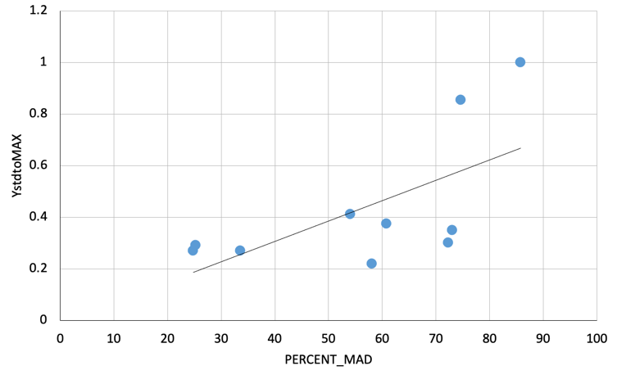
Summary: Mean Annual Discharge and

System Capacity for Atlantic Salmon

Stressor: Mean annual discharge (MAD; %)

Response: System Capacity (%)

Species: Atlantic Salmon (Salmo salar)

Life Stage: Egg

System: Catamaran Brook, NB, Canada

Function Derivation: Specifies the type of data used to develop the SR function. For example, experimental data, observational data, mechanistic theory, landscape correlation, expert elicitation, or a combination thereof.

Transferability of Function: Evaluate whether the function can effectively be extended to systems beyond the intended target. Discuss situations where transfer might be unsuitable. An SR function developed for one species may reasonably apply to closely related species or subspecies, which should be noted here. Additionally, authors should highlight if the SR function is exclusively applicable to a specific geographic area or population. Function authors must consider the transferability of the function among populations within a species AND determine the spatial scale over which it can be generalized (i.e., regional, provincial, continental)?

Model Validation: Describe whether the stress-response function has been validated through empirical testing on a population or with an independent dataset. Examples of function validation might include:

Unvalidated function: “Model unvalidated on an independent data set.”
Partial validation: “Predicts independent data regression fairly well. Cutthroat Trout smolts/km standardized from 0-1 are within 95% CIs, and very close at low flows, diverge somewhat at flows approaching the optimum. See “EmpiricalData1” worksheet.”
Good validation: “Model has been shown to generate good predictions on independent data. See AdditionalData1 in worksheet.”

Detailed SR Function Description

Derivation of the function:
This section should comprehensively outline the data, theory, mechanism, and pathways of effects underlying the SR function. While the sub-headings on the Summary page can be used as a guide to ensure complete coverage, this section is intended to be ‘free-form.’ Authors have flexibility to describe the function and its origins in their own way. However, the reader should be able to understand clearly the steps taken to derive the function, with citations and references to external information as appropriate. This written section should provide a transparent and detailed account of the methodologies employed in deriving the SR function. Original data and functions used to generate the stressor-response curve should be included separately, in the SRfunctionData Excel file. This supplementary file will display greater detail in the function derivation, including clear explanations of variables, data transformations, model fitting, and any other relevant processes.
Source of stressor data to apply the function:
Practical application of an SR function in CEMPRA requires that users obtain estimates of stressor levels (magnitude) in each watershed or spatial unit to use as the independent predictor variable to generate the predicted response. This is a key consideration in choosing a SR function, because even if the stressor-response function is well-defined and appropriate, it will be useless if the appropriate stressor data (or a proxy) is not available to estimate a response. Stressor data can be obtained through direct field measurements (e.g., temperature logger data), stressor estimates derived from models (e.g., temperature predictions based on longitude, aspect, and elevation), proxies obtained through remote sensing, or a quantitative relationship between the stressor and a GIS variable. This section guides users in identifying data sources suitable for populating the Stressor Magnitude File, which accompanies the Stressor-Response Workbook (housing SR functions) in a CEMPRA application. If the stressor magnitude (x-axis) is derived from a more easily measured proxy (or indicator) variable, this relationship should be noted, along with the likely strength of the correlation. For example, road density could serve as an indicator that represents the combined effects of sediment inputs, angler access, or fragmentation on stream habitats. If possible, include links to the databases where landscape data was collected. This optional section provides the SR function author the opportunity to tell potential users where they may be able to obtain stressor data.

Stressor-Response Function

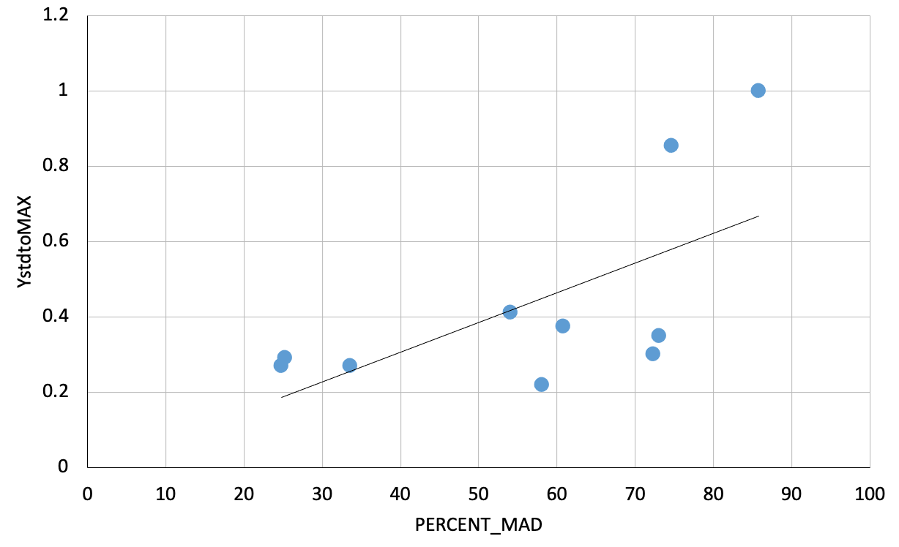
Figure 1: Display the final stressor-response function that was used in CEMPRA. If possible, display the original data used to derive the function, overlayed on this plot.

Stressor-Response Table

Table 1: Provide a table description of the data points in the SR function. Include all information that would be included in a standard table caption.
Mean Annual Discharge (%) | Mean System  Capacity (%) | SD | Lower Limit | Upper Limit
24.76323077 | 27.04107425 | 0 | 0 | 100
25.21738462 | 29.25592417 | 0 | 0 | 100
33.51446154 | 27.17061611 | 0 | 0 | 100
54.044 | 41.30331754 | 0 | 0 | 100
58.02938462 | 22.10110585 | 0 | 0 | 100
60.75584615 | 37.5971564 | 0 | 0 | 100
72.29323077 | 30.19273302 | 0 | 0 | 100
73.05092308 | 35.06319115 | 0 | 0 | 100
74.59430769 | 85.55292259 | 0 | 0 | 100
85.76938462 | 100 | 0 | 0 | 100

SR Function Confidence and Sources of Uncertainty
The table below outlines criteria for assessing confidence in the SR function. NOTE: These criteria serve as guidance for raking confidence in different aspects of the SR function but are not meant to be rigidly prescriptive. Not all criteria will be applicable, and authors should use their discretion in adding additional criteria, provided they maintain clarity and transparency in the information used for assessing confidence.
 |  | Low Confidence | Moderate Confidence | High Confidence
Data Source for SR Function | Evaluate confidence based on the precision, accuracy, quantity, and appropriateness of data used to build the SR function. Identify the origin of the function and associated data as professional opinion, consultation workshops, mechanistic/theory- based relationships, empirical studies, field sampling, or an alternative. Specify if peer-review was conducted and provide brief citations. | - Professional opinion from a limited number of experts, with loosely defined endpoints.  - Poorly matched laboratory studies.  - Hypothesized relationships from peer-reviewed literature that have not been empirically tested.  - Qualitative data only. | - Professional opinion from multiple experts and/or consultation workshops, providing moderate certainty in endpoints.  - Laboratory or mesocosm studies with moderate relevance to the system.  - Quantitative or semi-quantitative data. | - Direct data collection from the target system or a suitable proxy.  - Mesocosm or in situ experiments directly applicable to the target system.  - Multiple expert opinions reaching a consensus, providing well-supported mid- and endpoints  - Extensive, well-documented dataset used to construct the function.
Rationale --> | Please explain choice of ranking in this category.
Shape of SR Function | Assess confidence that the shape of the SR function is accurate (linear/non-linear; slope, inflections, intercepts, endpoints, midpoints, thresholds) | - Shape of function is likely correct, but there is high uncertainty in parameter estimates such as intercept, slope, and thresholds. | - Shape of function is likely correct with increasing confidence in parameter estimates, but significant potential for error. | - Relationship is well-supported and thoroughly documented.  - Model shows good fit.
Rationale --> | Please explain choice of ranking in this category.
Data Variance/  Consistency | Is there significant variance (spread) in the data around the function? Do all data sources show consistent patterns? | - High variance in data and/or inconsistency in shape of function across the data set. | - Moderate variance in data, some gaps in range of data across function.  - Variation in the shape of functions across data. | - Data sources show high consistency in shape, slope, inflections, and intercepts of the SR function.
Rationale --> | Please explain choice of ranking in this category.
Applicability to System | How well-matched are the source data and the target system? Are they the same species, watershed, season, life stage, etc.? | - Target species differed but is related to the species in data source.  - Geographic areas differ greatly between the source data and the target system (consider ecological similarities between disparate geographical areas). | - Target system involves the same species, but a different subspecies, ecotype, or population compared to the data source used for the SR function.  - Geographic proximity or partial overlap between the areas of the source data and the target system. | - Target system involves the same species, subspecies, or population as the data used to generate the function.  - Geographic areas are matched between the source data and the target system.
Rationale --> | Please explain choice of ranking in this category.
Potential Stressor Interactions | Is there potential for other unaccounted variables to interact with the stressor and influence the shape of the SR function?  Which stressors are likely to covary with the stressor in a biologically meaningful way? | - Potential for multiple additional variables whose interactions cannot reliably be determined. | - Interacting variables are probable, but the main effect of the stressor is likely to dominate the response. | - Effect of stressor is likely to be largely independent of other variables.
Rationale --> | Please explain choice of ranking in this category.

Recommended Citation
This document should be cited as:
Author, YEAR. [Stressor name] stressor-response function for [Species] [version #]. [Agency Name] CEMPRA model for [Species].
Example citation:
MacPherson, L. 2023. Sedimentation stressor-response function for Bull Trout version 2. AEP CEMPRA Model for Bull Trout.

_____________________________________________________________________________________________

References
Cunjak, R.A., Linnansaari, T., and Caissie, D. 2013. The complex interaction of ecology and
hydrology in a small catchment: a salmon's perspective. Hydrol. Process. 27: 741-749.

