Summary: Water Temperature and System Capacity for Salish Sucker
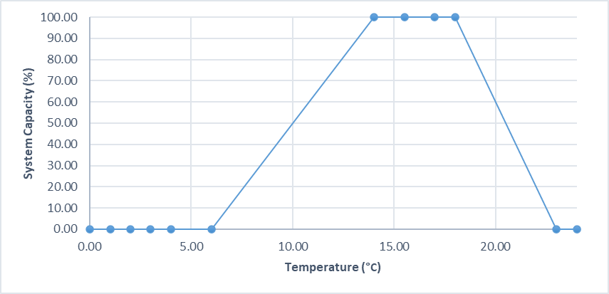

Stressor: Water Temperature

(ºC)

Response: System Capacity (%)

Species: Salish Sucker (Catostomus sp.)

Life Stage: Adult

System: Lower Fraser Valley, including the full distribution range of Salish Sucker

Function Derivation: Empirical data for Salish Sucker from lower Fraser Valley supported by the older generic published curve for Longnose Sucker from across North America.

Transferability of Function: As local adaptations are likely minimal among different Salish Sucker populations, we would not expect much variation in true tolerance among populations. This function should therefore be broadly applicable to all populations of the species, with the caveat that it is partly based on data from longnose sucker.

Model Validation: The model is not validated on independent data for Salish Sucker due to unavailability of such data.

Detailed SR Function Description:

Derivation of the function:

Three data sources of information were considered for deriving the final curve i.e., Pearson (2004), Rosenfeld et al. (2021) and Edwards (1983). In addition, we considered the expert opinion provided at the workshop conducted in November 2024. Maximum system capacity was defined by standardizing data to the highest value for CPUE (fish trap⁻¹). It should be noted that Salish sucker are thought to be somewhat more warm-adapted than Longnose sucker, which are much more widely distributed and considered to be a cool-water species; temperature data for Salish sucker appears to support this inference, since the temperature curve foe Salish sucker appears right-shifted to higher temperatures relative to Longnose sucker. The final curve was derived by fitting a Generalized Additive Model (GAM) to original CPUE data from Rosenfeld et al. (2021). The fitted GAM curve was marginally significant (p<0.1) with wide confidence intervals at the high and low temperature extremes, which is likely due to fewer data points at very low and high temperatures. However, we can be fairly confident that the confidence intervals are in fact likely low at very high and low temperatures, despite the wide intervals implied by the GAM. This is apparent in the narrower confidence intervals in the CPUE-temperature function fit to temperature classes in Rosenfeld et al. (2021; see Fig. 2 below). The lower and upper x-intercepts in the final function (temperature at which system capacity is 0, i.e., 6ºC and 23ºC respectively) were determined based on the upper and lower temperatures where fish were caught in traps (see supporting SR function Excel file, cells AK157 and AK 171). The habitat suitability index model for Longnose Sucker (Edwards 1983) provided additional supportive evidence for the shape of the function, as did superimposition of Pearson (2004) data on top of the CPUE-temperature SR function. The function was further modified based on input received at the expert workshop i.e. the response to temperature should be a step faction and therefore, the maximum system capacity (100%) should be a plateau rather than a peak. The temperature range of the plateau was chosen as 14 to 18°C (Sierra Sullivan and Mike Pearson, Pers. Comm., 2024).

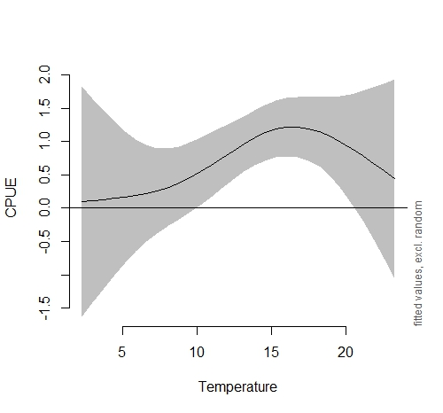

Figure 1: Output plot of the Generalized Additive Model for the relationship between mean water temperature (in degrees Celsius) and Salish Sucker CPUE. Solid line denotes the fitted trend (smooth function) and shaded region represents the pointwise 95% confidence intervals.
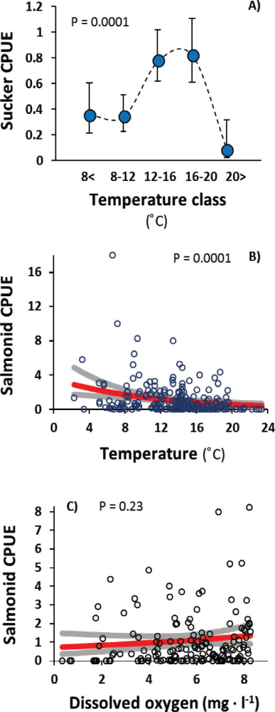
Figure 2: Plot from Rosenfeld et al. showing sucker CPUE vs. temperature in 5 discrete classes, demonstrating much tighter confidence intervals at high and low temperatures than indicated buy the Generalized Additive Model in Figure 1.

Source of stressor data to apply the function:

This is largely to be determined, but it will likely be a combination of data from Rosenfeld et al. (2021), data collected by Samantha Ramirez (2024) as part of her M.Sc. thesis, and a database of current and future projections produced by Dr. Iacarella with DFO and collaborators (currently unpublished, but see (Weller et al. (2023).

Stressor-Response Function

Figure 3: Stressor-response curve depicting the expected relationship between water temperature (in degrees Celsius) and the system capacity of Salish Sucker.
Stressor-Response Table
Table 1: Stressor response relationship reflecting the relationships between water temperature and system capacity for Salish Sucker populations.
Temperature (ºC) | System Capacity (%) | SD | Lower Limit | Upper Limit
0.00 | 0.00 | 0.00 | 0.00 | 0.00
1.00 | 0.00 | 0.00 | 0.00 | 0.00
2.00 | 0.00 | 0.00 | 0.00 | 0.00
3.00 | 0.00 | 0.00 | 0.00 | 0.00
4.00 | 0.00 | 0.00 | 0.00 | 0.00
6.00 | 0.00 | 0.00 | 0.00 | 0.00
8.50 | 25.41 | 0.00 | 0.00 | 71.31
10.00 | 40.16 | 0.00 | 3.28 | 89.34
12.67 | 68.85 | 0.00 | 50.82 | 105.74
14.00 | 85.25 | 0.00 | 50.82 | 123.77
15.50 | 96.72 | 0.00 | 63.11 | 132.79
17.00 | 100.00 | 0.00 | 63.11 | 134.43
18.50 | 94.26 | 0.00 | 58.20 | 134.43
23.00 | 0.00 | 0.00 | 0.00 | 0.00
24.00 | 0.00 | 0.00 | 0.00 | 0.00
0.00 | 0.00 | 0.00 | 0.00 | 0.00

SR Function Confidence and Sources of Uncertainty
The uncertainty assessment below is based on our evaluation of the available data and level of confidence in the derived function. These rankings should be reassessed if additional information becomes available.
 | Low Confidence | Moderate Confidence | High Confidence
Data Source for SR Function |  |  | X
Rationale --> | This function is based on empirical data for Salish Sucker from the study system (Pearson 2004, Rosenfeld et al. 2021).
Shape of SR Function |  |  | X
Rationale --> | The relationship between temperature and Salish Sucker CPUE identified by Rosenfeld et al. (2021), the Generalized Additive Model (GAM) fit to the original data of Rosenfeld et al. (2021), and data from Pearson (2004) support the overall shape of the function and inflection points. In addition, the shape of the habitat suitability index model for Longnose Sucker (Edwards, 1983) is generally consistent with the shape of the function, although not the intercepts since Salish sucker appear more warm-adapted.
Data Variance/  Consistency | X
Rationale --> | Variance around this function is largely unknown. However, both the Pearson (2004) and Rosenfeld et al. (2021) data fit well within the thermal envelope defined by the model. The Pearson (2004) data provides a good confirmatory fit that is robust to the data used to standardize it (see Excel function spreadsheet).
Applicability to System |  |  | X
Rationale --> | The target system involves the same species, populations and geographic area as the data sources used to derive the SR function.
Potential Stressor Interactions |  |  | X
Rationale --> | Temperature influences Dissolved Oxygen concentration in the water, which in turn influence system capacity of Salish Sucker. However, an independent stressor-response function has been derived for the effect of DO on system capacity of Salish Sucker.

Recommended Citation

This document should be cited as:
Usoof, A.M. and Rosenfeld, J.S. 2024. Relationship between system capacity and mean water temperature for Salish Sucker.
_____________________________________________________________________________________________

References

Edwards, E. A. 1983. Habitat Suitability Index Models: Longnose Sucker. U.S. Dept. Int., FishWildl. Serv. FWS/OBS-82/10.35.
Pearson, M. P. 2004. The ecology, status and recovery prospects of Noonsack Dace (Rhinichthys Cataractae ssp.) and Salish Sucker (Catostomus sp.) in Canada. PhD Thesis. University of British Columbia.
Ramirez, S. Z. 2024. Modelling the impact of human development and water quality on hypoxia. MSc Thesis. University of British Columbia.
Rosenfeld, J., M. P. Pearson, J. Miners, and K. Zinn. 2021. Effects of landscape-scale hypoxia on Salish sucker and salmonid habitat associations : implications for endangered 1233:1219–1233.
Weller, J. D., R. D. D. Moore, J. C. Iacarella, J. D. Weller, R. D. D. Moore, J. C. I. Nov, and J. D. Weller. 2023. Thermalscape scenarios for British Columbia , Canada. Canadian Water Resources Journal / Revue canadienne des ressources hydriques.

