Summary: Flood Recurrence Interval and Egg-to-Fry Survival

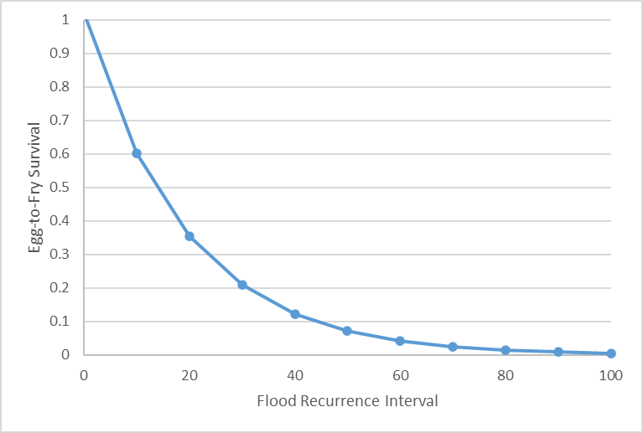
Stressor: Peak flow (flood) recurrence

interval (years)

Response: Egg-to-fry Survival

Species: Chinook Salmon

(Oncorhynchus tshawytscha)

Life Stage: eggs, fry

System: Skagit River, Washington

Function Derivation: empirical data

Transferability of Function: This function was derived from egg-to-migrant survival estimates from annual monitoring in the Skagit River. It could be applied with caution to other Chinook Salmon systems.

Model Validation: Model not validated on independent data.

Detailed SR Function Description

Derivation of the function:
“Effects of peak flows on egg to migrant fry survival have been documented in Chinook salmon in the Skagit River basin (Kinsel et al. 2007), and are presumed to reflect scour of eggs in the gravel due to the overlap in timing of floods and the incubation period. A similar effect is presumed to occur in other river basins. The data from the Skagit River basin are shown in Figure I.9, along with predicted survivals using an exponential regression relationship. Note that the recurrence interval on the x-axis is based on the Skagit River near Mount Vernon, which is low on the mainstem Skagit.
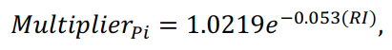
In the Chehalis basin, we rescale this relationship to create a multiplier that ranges from 1
at RI = 0 to near zero at RI = 100 (Figure I.10). The equation for the relationship is:

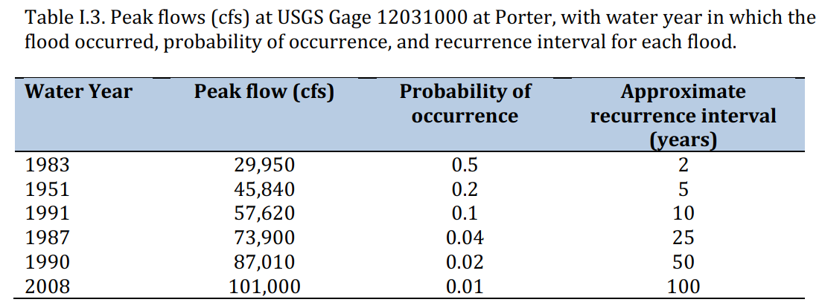
where Multiplier_{Pi} is the incubation productivity multiplier and RI is the flood recurrence
interval. In each year of the model run, the multiplier is then calculated using this function,
based on the flood recurrence interval for that year. We used peak flow at the USGS gage on
the Chehalis River at Porter as the index flow. Peak flows, probabilities of occurrence, and
recurrence intervals were calculated using the PeakFQ USGS software (https://water.usgs.gov/software/PeakFQ/). Results for that gage are shown in Table I.3.” (Beechie et al. 2021, p. 230)

Source of stressor data to apply the function:
This function is not currently being used in CEMPRA or in the Beechie NOAA model. Stressor magnitude data could be extracted from USGS hydro gauge data.

Stressor-Response Function
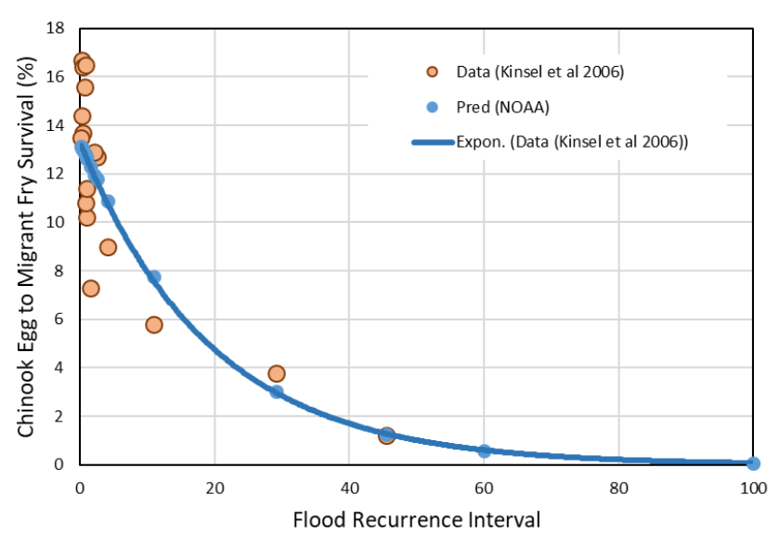

Figure 1: Relationship between Chinook egg-to-fry survival and flood recurrence interval in the Skagit River basin from Kinsel et al. (2007). The predicted survival rates (blue dots) are derived from the fitted exponential curve (blue line). Flood recurrence interval on the X-axis is for the Skagit River gauge at Mount Vernon.
Stressor-Response Table
Table 1: Stressor response relationship reflecting egg-to-fry survival in Chinook Salmon and flood recurrence interval.
Flood Recurrence Interval | System Capacity (%) | SD | Lower Limit | Upper Limit
8 | 1 | 0 | 0 | 100
10 | 1 | 0 | 0 | 100
12 | 1 | 0 | 0 | 100
14 | 1 | 0 | 0 | 100
16 | 1 | 0 | 0 | 100
18 | 1 | 0 | 0 | 100
20 | 0.66 | 0 | 0 | 100
22 | 0.32 | 0 | 0 | 100
24 | 0 | 0 | 0 | 100
26 | 0 | 0 | 0 | 100
28 | 0 | 0 | 0 | 100
30 | 0 | 0 | 0 | 100
32 | 0 | 0 | 0 | 100

SR Function Confidence and Sources of Uncertainty
This uncertainty rubric was populated based on a summary report, not by the authors of the function with the original data. These rankings should be reassessed if additional information is available.
 | Low Confidence | Moderate Confidence | High Confidence
Data Source for SR Function |  | X
Rationale --> | The function was based on egg-to-migrant survival estimates from annual monitoring in the Skagit River. It was collected from a single location, so may not capture broader variability in the relationship with peak flow events.
Shape of SR Function |  | X
Rationale --> | The function is negative, but precise shape is uncertain without additional data from rare flood events.
Data Variance/  Consistency |  | X
Rationale --> | Data variability is moderate for low-interval floods and low for high-interval floods, but this may be due to a paucity of data for rare flood events.
Applicability to System
Rationale --> | This function was not applied in CEMPRA nor in the Beechie NOAA model.
Potential Stressor Interactions | X
Rationale --> | Stressor interactions are likely due to the nature of empirical landscape data.

Recommended Citation
This document should be cited as:
CEMPRA Team 2024. Relationship between egg-to-migrant survival and peak flow (flood) events for juvenile Chinook Salmon.

_____________________________________________________________________________________________

References

Beechie, T. J., C. Nicol, C. Fogel, J. Jorgensen, J. Thompson, G. Seixas, J. Chamberlin, J. Hall, B. Timpane-Padgham, P. Kiffney, S. Kubo, and J. Keaton. 2021. Modeling Effects of Habitat Change and Restoration Alternatives on Salmon in the Chehalis River Basin Using a Salmonid Life-Cycle Model. U.S. Department of Commerce, NOAA Contract Report NMFS-NWFSC-CR-2021-01.

Kinsel, C., G. Volkhardt, L. Kishimoto, and P. Topping. 2007. 2006 Skagit River Wild Salmon
Production Evaluation. Washington Department of Fish and Wildlife, FPA 07-05,
Olympia, WA.

